The paper’s title should be the fewest possible words that accurately describe the content of the paper (Center, Bold, 14pt)

Sereyrath Em¹, Pisith Chin², Dina Pen³ (12 pt)
¹Institute of Social Technology, Suranaree University of Technology, Nakhon Ratchasima, Thailand (10 pt)
²National University of Cheasim Kamchaymear, Kampong Cham Campus, Cambodia
³Svay Rieng University, Svay Rieng Province, Cambodia

Article Info |  | Abstract (10 pt)
Article history:  Received:  Revised:  Accepted: |  | An abstract is often presented separately from the article, so it must be able to stand alone. A well-prepared abstract enables the reader to quickly and accurately identify the basic content of a document, determine its relevance to their interests, and thus decide whether to read the document in its entirety. The abstract should be informative and completely self-explanatory, provide a clear statement of the problem, and the proposed approach or solution, and point out major findings and conclusions. The Abstract should not be more than 250 words in length. References should be avoided, but if essential, cite the author(s) and year(s). Standard nomenclature should be used, and non-standard or uncommon abbreviations should be avoided, but if essential they must be defined at their first mention in the abstract itself. No literature should be cited. The keyword list provides the opportunity to add 5 to 7 keywords, used by the indexing and abstracting services, in addition to those already present in the title (10 pt).
Keywords:
First keyword
Second keyword
Third keyword
Fourth keyword
Fifth keyword

Article type:
Review article/Research article
This is an open-access article under the CC BY-SA license.

Corresponding Author:
Sereyrath Em
Institute of Social Technology, Suranaree University of Technology, Nakhon Ratchasima, Thailand
Email: sereyrathem.edu@gmail.com

1. Introduction
The introduction should include……
1.1. Background information
Start by introducing the broad topic area and provide relevant background information to give readers the necessary context. This helps them understand the significance of your research.
1.2. Research gap
Identify and highlight the gap in existing knowledge or the unanswered question that your study aims to address. Explain why this gap is important and how your research fills it.
1.3. Research objectives
There must be at least one research objective in this study.
1.4. Research questions
There must be at least one research question in this study.
1.5. Significance of the study
Discuss the importance and potential implications of your research. Explain how your findings could contribute to the field or address real-world problems.

2. Literature review
The literature review critically evaluates and synthesizes existing research relevant to the study. The key elements that should typically include.
Introduction to the literature review: start by introducing the purpose of the literature review and its significance in the context of your research. Explain why understanding previous research is essential for your study.
Organization and structure: provide an overview of how you have organized the literature review section. This could be chronological, thematic, theoretical, methodological, or any other appropriate structure.
Background and context: provide background information on the topic area and establish the context for your review. Discuss key concepts, theories, and definitions relevant to your study.
Inclusion criteria: explain the criteria you used to select the literature included in your review. This might include publication dates, types of sources (e.g., peer-reviewed journals, books, conference proceedings), and relevance to your research questions.
Synthesis of literature: summarize and synthesize the findings of the selected studies. Identify common themes, trends, and patterns in the literature. Compare and contrast different studies' methodologies, results, and conclusions.
Critical evaluation: evaluate the strengths and weaknesses of the existing literature. Critically analyze the methodologies used, the validity of the findings, and any limitations of the studies reviewed.
Identification of gaps: identify gaps or areas where the existing literature falls short. This could include unanswered research questions, contradictory findings, or underexplored aspects of the topic.
Theoretical framework: if applicable, discuss the theoretical frameworks or conceptual models used in the literature and how they relate to your research.
Implications for your study: discuss how the findings of the reviewed literature inform your research questions, hypotheses, or methodology. Explain how your study builds upon or diverges from previous research.

3. Methodology
(Authors must follow the subtitles in this section for the research articles)
3.1. Research Design

3.2. Samples and Sampling Techniques

3.3. Instruments

3.4. Data Collection Procedures

3.5. Data analysis

3.6. Ethical Consideration

4. Findings
4.1. Subheading (research question 1)

4.2. Subheading (research question 2)

4.3…..
Figures and Tables
Use good-quality images and give a caption below the image.

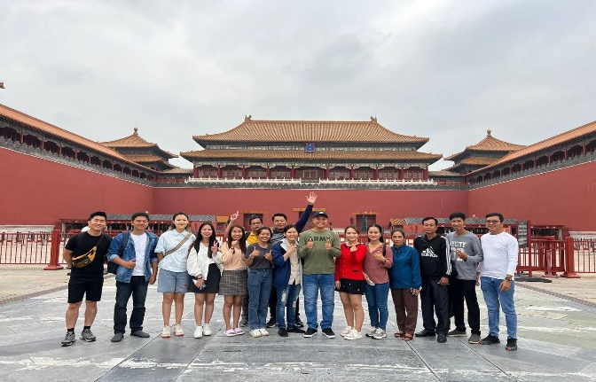
Figure 1 (Bold). Title of the image (Book Antiqua, Font 12, Centered, Single-spaced)
(Source of image – Book Antiqua, Font 10, Centered, Single-spaced)

The caption for the table must be above the table.

Table 1 (Bold). Title of the table (Book Antiqua, Font 12, Centered, Single-spaced)
No. | Indication | Frequency | Percentage (%)
1 | Very positive | 19 | 47.5%
2 | Positive | 15 | 37.5%
3 | Neutral | 4 | 10%
4 | Negative | 1 | 2.5%
5 | Very Negative | 1 | 2.5%
Total |  | 40 | 100%

The caption for the chart must be above the chart.

Chart 1 (Bold). Title of the chart (Book Antiqua, Font 12, Centered, Single-spaced)
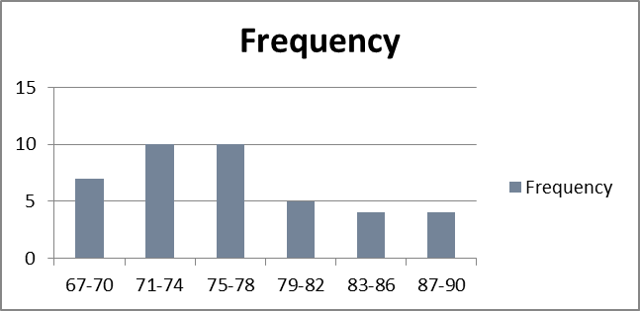

5. Discussion
Present logical analysis of findings of the study. Provide evidence to support your analysis by citing the work of previous studies or existing theories. [Explain whether your results agree or disagree with previous studies, and why].

6. Conclusion and recommendation
Clearly state how the objectives of the study are accomplished.

7. Limitations and future studies
No study covers all aspects of the research problem. Therefore, the author needs to discuss the limitations or gaps of this study. A plan or future scope of the study should also be provided.

Acknowledgments
Indicate the source of funding or help received in carrying out your study and/or preparing the manuscript if any before the references. We suggest all co-authors mention their contribution to the article to avoid ghostwriting.

References
(APA Style 7th Edition)

Appendix
(Optional)

